**Practical-1**

**Aim: Write a C program to input any character and check whether it is the alphabet, digit, or special character.**

**Program:**

#include<stdio.h>

#include<conio.h>

#define p printf

#define s scanf

main()

{

char ch;

clrscr();

p("Enter any words");

s("%c",&ch);

if(ch>='a' && ch<='z'|| ch>='A' && ch<='Z')

{

p("%c IS ALPHABET",ch);

}

else if(ch>='0' && ch<='9')

{

p("%c IS DIGIT",ch);

}

else

{

p(" %c IS SPECIAL CHARACTER",ch);

}

getch();

}

**Output:**

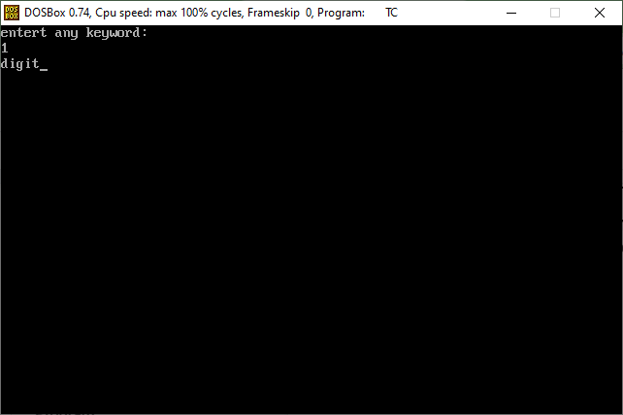

**Practical-2**

**Aim**:Write a C program to check a number is even or odd using the ternary operator.

**Program:**

#include<stdio.h>

#include<conio.h>

void main()

{

int a;

clrscr();

printf("enter value of a:-");

scanf("%i",&a);

(a%2==0)

?printf(“even”)

:printf(“odd”);

getch();

}

**Output:**

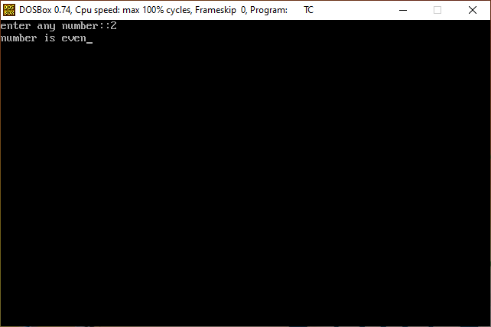

**Practical-3**

**Aim:Write a C program to convert temperature from degree Celsius to Fahrenheit.**

**Program:**

#include<stdio.h>

#include<conio.h>

#define p printf

#define s scanf

main()

{

int a,b,c,d;

clrscr();

p("Enter 4 number values");

s("%d%d%d%d",&a,&b,&c,&d);

(a>b)

?(a>c)

?(a>d)

?p("A is max")

:p("B is max")

:p("C is max")

:(b>c)

?(b>d)

?p("B is max")

:p("C is max")

:(c>d)

?p("C is max")

:p("D is max");

getch();

}

**Output:**

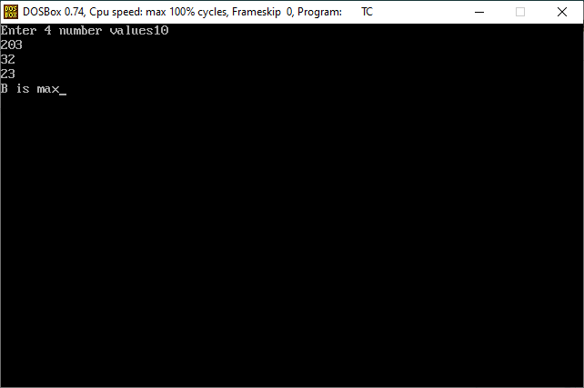

**Practical-4**

**Aim: Write C program use switch statement. Display months name. Also, provide proper validation layers.**

**Ex. User Input: M**

**Output: March**

**Program:**

#include<stdio.h>

#include<conio.h>

void main()

{

char month;

clrscr();

printf("J for January\n");

printf("F for Febuary\n");

printf("M for March\n");

printf("A for April\n");

printf("m for May\n");

printf("j for June\n");

printf("U for july\n");

printf("a for August\n");

printf("S for September\n");

printf("O for Octomber\n");

printf("N for November\n");

printf("D for December\n");

printf("Enter any word");

scanf("%c",&month);

switch(month)

{

case 'J':

printf("January");

break;

case 'F':

printf("Febuary");

break;

case 'M':

printf("March");

break;

case 'A':

printf("April");

break;

case 'm':

printf("May");

break;

case 'j':

printf("June");

break;

case 'U':

printf("July");

break;

case 'a':

printf("August");

break;

case 'S':

printf("September");

break;

case 'O':

printf("Octomber");

break;

case 'N':

printf("November");

break;

case 'D':

printf("December");

break;

default:

printf("invalid Month");

}

getch();

}

**Output:**

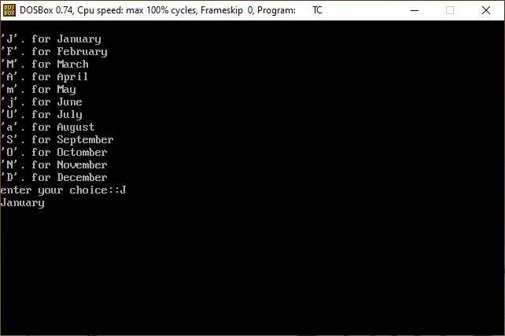

**Practical-5**

**Aim:Write a C program to input electricity unit charges and calculate the total electricity bill according to the given condition:**

**For the first 50 units Rs. 0.50/unit**

**For the next 100 units Rs. 0.75/unit**

**An additional surcharge of 20% is added to the bill.**

**Program:**

#include<stdio.h>

#include<conio.h>

void main()

{

float unit,r,amount,tax,total;

clrscr();

printf("Enter your unit:-",unit);

scanf("%f",&unit);

if(unit>=0 && unit<=50)

{

r=0.50;

}

else if(unit>50 && unit<=100)

{

r=0.75;

}

printf(“rate =%f\n”,r);

amount=unit*r;

printf("amount = %f\n",amount);

tax=(amount*20)/100;

printf("tax = %f\n",tax);

total=amount+tax;

printf("total = %f\n",total);

getch();

**Output:**

